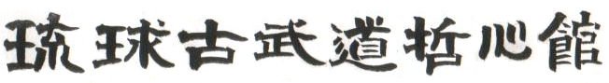
22nd Annual Ryukyu Kobudo Tesshinkan Aki Gasshuku
Sept.30- Oct 2nd 2016 Chilliwack BC
Tamayose Sense and Masako will arrive Sept. 26. Chilliwack seminar will begin Friday Sept 30 at 4pm at the Atchelitz Hall on Lickman Rd.
This year the Tesshinkan members are welcome to practice Friday but the practice will be dedicated to the ShibuCho.
Tamayose will teach two seminars, Saturday and Sunday.
Friday will be taught by senior Yudansha
There will be a ShibuCho meeting following the Friday practice.
We will begin Saturday morning at 10am Oct.1 and lunch will be 1pm – 2pm.
Dan testing will begin at 6pm followed by dinner at ??
Certification will be awarded on Sunday morning with practice beginning at 9am.
If you intend to test for Dan or Kyu rank, applications must be forwarded to me at least 30 days in advance to allow us to schedule time. From now on all grading fee’s must be paid in Yen!! So please talk to your banks well in advance.
As usual I am open to suggestions to make the annual Gasshuku the best it can be for everyone.
For those of you from out of town that are going to be staying in Chilliwack may I suggest the Vedder River Inn. It’s all new and at a reasonable sports group rate. $80 for a kitchenette and two double beds. Call Lori 800 591 7999 and mention Tesshinkan. www.vedderriverinn.com. Rainbow Best Western and Hampton Inn are also nearby.
Brian and Lisa Ash will host Tamayose Sensei for a seminar in Bozeman Montana the following weekend Oct 7,8,9. Hope to see many of you there. For info contact Brian ashkarate@msn.com Tesshinkan Seminar 2016 Flyer.pdf
Tesshinkan Seminar 2016 Registration Form.pdf

